REAL ESTATE EDUCATORS ASSOCIATION
Annual Conference
2011

LAW UPDATE 2011

Charles J. Jacobus
6750 West Loop South, Suite 615
Bellaire, Texas 77401

Special thanks and acknowledgment for the substantial contribution goes to Patrick A. Randolph, Jr., Professor of Law, University of Missouri, Kansas City, Law School, who edits a Quarterly Report on Developments in Real Estate, and the Decisions Committee of the ABA Section of Real Property, Probate & Trust Law, which supports the Report.

TABLE OF CONTENTS

I. BROKERS 1
A. As-Is; Attorney’s Fees 1
B. Duty to Warn 1
C. Special Agency, Ratification 2
II. EMINENT DOMAIN 2
III. LAND USE PLANNING, ZONING, AND RESTRICTIONS 4
IV. LANDLORD/TENANT 4
A. Roommates; Termination 4
B. Surrender 5
V. MORTGAGES 6
A. Assignments Of Rents; Foreclosure Purchasers 6
B. Foreclosures 6
C. MERS 8
1. BANKRUPTCY 9
VI. OPTIONS; RIGHTS OF FIRST REFUSAL; RULE AGAINST PERPETUITIES 10
VII. TITLE INSURANCE; AGENT LIABILITY; CLOSING ATTORNEYS 11
VIII. VENDOR/PURCHASER 11
IX. TAX-FREE MORTGAGE WORKOUTS 14
X. UNEARNED INCOME MEDICARE CONTRIBUTION 15
XI. PROTECTING TENANTS AT FORECLOSURE ACT 18
TABLE OF CASES 19

I. BROKERS

A. As-Is; Attorney’s Fees

In Boehl vs. Boley, et al., 2011 WL 238348 (Tex. App. –Amarillo, 2011), the Boehls, buyers, sought damages arising from misrepresentations and omissions with respect to the home they bought from Boley. The parties used a One to Four Family Texas TREC form. Prior to signing the contract, Boley represented to the Boehls that everything in his home works the way it should work, that the water well had 280 feet of water in it, and that he hadn’t had any problems with the well. Within a month after closing, the Boehls began experiencing shortages of water. A further investigation revealed that the well was going dry and needed extensive repairs. They sued for fraud, DTPA violations, fraudulent inducement, negligent and fraudulent representations, and breach of contract. The sellers responded by saying the property was an “as is” sale and the court granted summary judgment for the seller. The court reconfirmed a long line of Texas cases stating that the TREC contract, using the language “in its current condition”, has been construed to be an “as is” agreement. The court further noted that both parties were represented by real estate agents and that the Boehls paid extra for an option to withdraw from the transaction (Paragraph 23). The court further pointed there was no evidence illustrating that Boley knew the actual condition of the well, and further noted that the buyer did not have the well inspected.

Perhaps the best holding in the case was for Coldwell Banker. The trial court awarded attorney’s fees to Coldwell Banker when it found that the Coldwell Banker was the prevailing party and owed no damages to the buyers, citing the TREC form “the prevailing party in any legal proceeding relating to this contract is entitled to recover reasonable attorney’s fees and all costs of such proceeding incurred by the prevailing party.” The court held that such language permits real estate brokers to recover attorney’s fees as long as they are the prevailing party in a legal proceeding related to the contract. The court noted that since the contract was an “as is” contact, which was used as a defense by the sellers and the brokers, it was clearly related to the contract.

B. Duty to Warn

In Reyes vs. Egner, 201 N.J. 417, 991 A.2d 216 (2010), a renter entered into a short term lease agreement for a house at the Jersey Shore. Sheintended to occupy it, along with her family, for a vacation over the Labor Day weekend. The house had an elevated rear deck adjacent to the master bedroom. The deck was accessible through a sliding glass door in the master bedroom which led to a small wooden platform on the top of the deck. The platform was about seven inches below the door frame, and there was another six and one-half inch drop from the platform to the deck. There were no handrails attached to the platform or the deck.

On their ninth day at the house, the renter’s father, for the first time, opened the sliding glass door to go out onto the deck. He fell down the stairs and permanently injured his back. The father then sued the properly owners and the broker for negligence, breach of implied warranty of habitability, and violations of the Consumer Fraud Act. The lower court found that, as a mater of law, neither the home owners nor the broker had a duty to conduct a reasonable inspection of the property for hazardous conditions before renting it out. The father appealed.

The Appellate Division affirmed summary judgment for the broker, and remanded as to the homeowners.

With respect to the broker liability issue, the Appellate Division noted that a prior New Jersey Supreme Court case, Hopkins vs. Fox & Lazo Realtors, imposed a duty of care upon real estate agents conducting open houses to attract potential home buyers to inspect the property and warn about reasonably discoverable dangerous conditions. In Hopkins, the Supreme Court extended a duty of care to broker based on a fairness inquiry that balanced four factors: (1) the nature of the parties’ relationship; (2) the nature and foreseeabilily of the risk; (3) the existence of an opportunity to inspect and warn; and (4) the public policy behind the duty. The Court imposed a duty of care upon brokers to protect invited visitors to open houses because the nature and duration of their visit would not afford them the opportunity to recognize the dangerous conditions for themselves. However, the Appellate Division refused to extend the duty to warn to brokers that facilitate short term leases of summer rental property. The Appellate Division deferred to the Supreme Court to determine whether or not the Hopkins duty to warn should be extended to short-term rentals.

The Supreme Court granted certification, was deadlocked, and therefore the Appellate Division decision was affirmed. The Court’s refusal to extend the Hopkins duty to warn was not based on the Court’s conviction that the duty be limited to instances where a broker is holding an open house for potential buyers. Rather, the Court’s decision not to extend the duty to warn was limited to the facts of this case. The Court found no obligation to warn in this case because the renters were in the house for nine days before the accident occurred. Therefore, they had ample time to inspect the property for themselves to find any dangerous conditions.

C. Special Agency, Ratification

In Joseph vs. James, 2009 WL 3682608 (Tex. App. –Austin, 2009), the buyers sued the seller and the seller’s agent for breach of contract and real estate fraud pursuant to Chapter 27 of the Texas Business and Commerce Code. The trial court granted a motion for summary judgment for the defendants.

The facts in this case are so common!

The buyers, through their real estate agent, faxed an offer to purchase Joseph’s home in the amount of $1,875,000. The next day, the seller’s agent informed the buyers’ agent that the seller would not consider an offer of less than $2,000,000. After consulting with the buyers, the buyers’ agent drew a line through the figures and changed the sales price to $2,000,000. The buyers did not initial these changes or re-sign the contract. Upon receipt of the modified offer, the seller made several changes, including raising the sales price to $2,195,000. The seller initialed each change and sent the form back to the buyers’ agent. The buyers’ agent again drew a line through the figures of the first page of the form, and changed the total sales price to $2,100,000. Again, the buyers did not initial these changes. The buyers’ agent attached the form to an email to the seller’s agent saying that the buyers love the home and are countering at $2,100,000 with no other changes to your client’s counter. The seller’s agent sent an email to the buyers’ agent acknowledging that the seller accepts the offer of $2,100,000.

When the transaction did not go forward, the buyers’ agent stated that he did not have the buyers’ permission to make these changes to the contract and that sending the contract to the seller’s agent was a mistake. He said he was sorry for the confusion! The seller sued for breach of contract and fraud. The court first looked at the issue of statute of frauds wherein the court noted that the changes were never initialed, but the seller argued that the agent had the authority to sign on behalf of the buyer and by sending the information, bound the buyer. The court relied on a long line of Texas cases confirming that a real estate agent was a special agent, not a general agent, and therefore, could not bind a principal to a transaction. The seller also tried to argue ratification, but the court clarified that issue. Ratification is the adoption of confirmation by a person of a prior act that he had the right to repudiate. This was not the case here; it was all done during the heat of a negotiation.

II. EMINENT DOMAIN

In Alewine vs. City of Houston, 309 S.W.3d 771 (Tex. App. – 2010), in November 2003, the Houston’s Bush Intercontinental Airport opened a new east-west runway. The flight path for some of the aircraft which used the new runway extended over the southwest tip of nearby Woodcreek Subdivision and through the airspace of a few homes in the Subdivision. Due to the opening of the new runway, the Subdivision experienced a large increase in the number of airplanes passing over its homes. On October 31, 2005, several Subdivision residents (the “Plaintiffs”) filed suit against the City of Houston, alleging intentional nuisance and inverse condemnation. The Plaintiffs alleged that by building a new runway and thereby increasing overflights, the City took their property without just compensation in violation of the Texas Constitution.

At trial, the City argued that the City’s actions did not rise to the level of a constitutional taking because the Plaintiffs homes remain habitable, no taking occurred because the average noise level in the neighborhood did not exceed that approved by the federal government, and the “community damages rule” barred recovery since all of the Plaintiffs claimed similar injuries. The trial court granted summary judgment in favor of the City without specifying the basis for its ruling. Plaintiffs appealed.

The court began by deciding upon the appropriate legal test to prove a “taking-by-overflight” claim. Because the City did not file condemnation proceedings seeking to acquire the Plaintiffs’ property, the court determined that “this case would more appropriately be described as an ‘inverse condemnation’ action, in which an owner claims his property has already been taken-outside the proper condemnation proceedings-without compensation.” The court noted that in order to recover on an inverse condemnation action, “a claimant must plead and prove (1) an intentional governmental act; (2) resulted in a ‘taking’ of his property; (3) for public use.” In the subject case, the resolution of the takings claim turned on element (2), “the proof necessary to establish a ‘taking’ of property by airplane overflights.”

With regard to when airplane overflights become a “taking,” the Texas Court of Appeals first discussed authority from the U.S. Supreme Court. The seminal U.S. Supreme Court case in this area was decided in 1946, in which the owners of a chicken ranch were forced out of business because noise generated by low overflights resulted in scores of chickens flying into walls due to fright. In addition, the owners were frequently unable to sleep and became frightened and nervous as well. The Supreme Court found the facts of the case to be sufficient to establish a Fifth Amendment taking, but did not define the outer boundary of proof necessary to show a taking.

Similarly, in subsequent cases, the Supreme Court concluded a “taking” occurred because frequent low-altitude overflights rendered the affected property unusable for residential purposes. However, in each of those cases, the Supreme Court failed to describe which amount of evidence is necessary for a plaintiff to prevail in an inverse condemnation claim.

In 2002, the Texas Supreme Court addressed the issue in City of Austin v. Travis County Landfill Co. (“TCLC”). In TCLC, the plaintiff owned property a half mile from Austin-Bergstrom International Airport, which it intended to operate as a landfill. When the airport began accepting civilian air traffic, the plaintiff sued the City of Austin for an alleged taking. Despite the jury’s finding of a compensable taking and accompanying damage award, the Texas Supreme Court granted the City’s petition for review “to decide whether TCLC established that the civilian overflights . . . constituted a taking under the Texas Constitution,” In that case, the court recited the following legal standard:

“[T]o establish a taking by aircraft overflights, a landowner must show that the flights directly, immediately, and substantially interfere with the land’s use and enjoyment. To meet this standard, the landowner must show that the overflight effects directly and immediately impact the land so that the property is no longer usable for its intended purpose.” (emphasis added).

Applying this precedent, the Texas Court of Appeals held that because the homeowners did not show they could not live in their homes because of the overflights, none of the houses in the neighborhood were vacant, and that roughly half of the homes in the neighborhood had increased in value, the homeowners did not meet the evidentiary standard required to show a constitutional taking.

III. LAND USE PLANNING, ZONING, AND RESTRICTIONS

In Barr vs. City of Sinton, 295 S.W.3d 334 (Tex.App.-Corpus Christi-Edinburg 2005, pet. granted), Pastor Barr operated two houses inside the City for parolees and probationers. The houses are located across the street from Pastor Barr’s sponsoring church. The City enacted an ordinance that prohibits locating a correctional or rehabilitation facility with 1,000 feet of certain land areas. The houses violated the ordinance.

Pastor Barr claims the ordinance violated his freedom of worship under the federal constitution. The United States Supreme Court has concluded that an individual’s religious beliefs do not excuse him from compliance with an otherwise valid law prohibiting conduct that the State is free to regulate. Because the City’s zoning ordinance is a valid law prohibiting conduct that it is free to regulate, and because it is generally applicable to any person desiring to operate correctional or rehabilitation facilities, the court concluded that Pastor Barr’s freedom of religion claims lack merit.

Pastor Barr also contends that the ordinance not only impacts his freedom of worship but also his freedom of speech. He asserts that it is his underlying act of conveying a Christian message in the homes-his purpose or motivation for the homes’ existence-that, in this case, prohibits the housing of persons who have been convicted of misdemeanors or felonies within one year of being released from any penal institution. Pastor Barr urges that the ordinance punishes the Christian thought or message behind the act, not the act of housing itself, and that it is what is spoken inside the homes that puts him in violation of the ordinance. He contends, therefore, that the ordinance is content based, not content neutral, and should have been reviewed under a strict scrutiny standard.

Assuming without determining whether the state constitution’s freedom of speech clause is applicable in this case, the issue is whether the ordinance is content neutral or content based. In making the determination of what is content neutral, the standard is whether the government has adopted a regulation of speech because of disagreement with the message it conveys. The government’s purpose is the controlling consideration. In this case, the court found nothing in the record that would establish that the City adopted the ordinance to regulate speech because it disagreed with the Christian message Pastor Barr was conveying or with his motivation to clothe, house, and feed the needy. The purpose of the legislation was not to stifle speech but rather to protect the public by regulating the location of correctional and rehabilitation facilities. It is this purpose that controls. Furthermore, First Amendment cases recognize that statutes may also be content neutral because they are justified without reference to the content of the regulated speech. The ordinance in this case does not reference the content of the regulated speech, if any.

Pastor Barr also contends the ordinance prohibits people who have been incarcerated from living together or assembling in homes governed by Christian principles because that is the purpose of the homes’ existence. However, the constitutional rights of assembly and association do not extend a right for unrelated persons to live together in violation of a municipal zoning ordinance.

Finally, Pastor Barr complains that the ordinance violates section 3 and section 3a of the constitution because he was treated unequally as compared to someone who intends to house the same people but for a different purpose, i.e., profit v. ministry. However, there is nothing in the record showing that a similarly situated class has been treated differently in this case. Furthermore, the court cannot conclude that the ordinance affects one class differently from any other class that is attempting to house groups of previously incarcerated persons.

IV. LANDLORD/TENANT

A. Roommates; Termination

In Tiller vs. Shuboney, 894 N.Y.S.2d 342 (N.Y. City Ct. 2009), Plaintiff and Defendant, both college students, agreed to rent an apartment together. Only Defendant signed the approximately year long lease for the apartment, but the landlord was notified that Plaintiff was living in the apartment and Plaintiff verbally agreed to pay half the costs associated with renting the apartment. There was no written or verbal agreement regarding the obligations of either party in the event that one of the parties wanted to move out before the lease expired.

After months of living together, tensions increased amongst the two parties and relations deteriorated. Plaintiff left the apartment for winter break and upon her return to the apartment, she learned that Defendant had changed the locks. Defendant’s mother answered the door and told Plaintiff that Plaintiff would have to move out of the apartment.

Plaintiff and Defendant later exchanged letters regarding the removal of Plaintiff’s belongings from the apartment and in one of such letters Defendant threatened that if Plaintiff did not remove Plaintiff’s belongings by a certain date, such belongings would be moved to the basement. When Plaintiff arrived at the apartment to pick up her belongings, she found all her belongings in the basement and she noticed that some items were damaged.

After being ousted from the apartment, Plaintiff moved back home with her mother and was unable to complete the rest of the academic semester because of the distance between her mother’s home and the college.

Plaintiff sued Defendant for damages. According to the court, a contractual relationship existed between Plaintiff and Defendant and Plaintiff was the sublessee of Defendant. The court determined that: (i) as Defendants sublessee, Plaintiff was entitled to the same legal protections from Defendant that Defendant was entitled to from her landlord and (ii) Defendant was also required to provide the same legal protections to Plaintiff that Defendant’s landlord was required to provide to Defendant, which protections included the right to have a minimum of 30 days notice prior to an eviction and the right to not be ejected from an apartment without a court order. Since Defendant accepted Plaintiff’s rent during the month in which she locked Plaintiff out of the apartment, did not give Plaintiff sufficient notice and did not obtain a court order of eviction the Court determined that Defendant was not legally entitled to oust Plaintiff from the apartment and Plaintiff was entitled to damages.

B. Surrender

In Sirdah vs. North Springs Associates, LLLP, 2010 WL 2278184 (Ga. App. 6/8/10), the tenant wrote to its landlord that it “would no longer be open for business”. In that same letter the tenant returned the keys and specifically wrote: “I am turning in my keys to the premises”. In response, the landlord, by certified letter, notified the tenant as follows: “be advised that although (the tenant] has given up possession of the premises through return of his key, [the landlord] has accepted sane without terminating the Leases. The landlord [intends to hold the tenant) liable for all sums due and owing through the expiration of the term of the Leases, together with any damages to the premises, to be reduced only by sums received by [the landlord] through reletting of said premises.”

The Court rejected the tenant’s assertion that be had “given up possession of the premises through his return of his key” and that the landlord “accepted same.” In essence, the tenant argued that the Landlord was then required to “have made reasonable efforts to re-let the premises.”

The Court noted: “The mere taking of the keys to the leased premises by a landlord does not give rise to an inference that the landlord accepted surrender of the premises. …Likewise, ‘[t]he mere entry upon the premises to protect the property after abandonment by the lessee will not amount to an acceptance of a surrender of a lease.’” In addition to looking at the subjective intent of the landlord, the Court pointed to the landlord’s response letter wherein it expressly said that it was not terminating the leases. Fundamentally, to the Court, there was uncontradicted evidence that the landlord neither expressly nor impliedly accepted the tenant’s surrender of the leased premises.

The Landlord is not required to mitigate damages under Georgia Law. To reinforce its reasoning, the Court pointed to a Bankruptcy Court decision in the Southern District of Georgia which recited: “surrender differs from abandonment, as applied to leased premises, inasmuch as the latter is simply an act on the part of the lessee alone; but to show a surrender, a mutual agreement between a lessor and a lessee that the lease is terminated must be clearly proved.”

V. MORTGAGES

A. Assignments Of Rents; Foreclosure Purchasers

In Higdon vs. Regions Bank, ___ S.W. 3d ___, 2010 Westlaw 1924019 (Tenn. Ct. App. 5/13/10), The Stinnetts refinanced an existing deed of trust loan on their Property with a loan obtained from ORNL. On September 9, 1999. Weather Tamer advanced additional money to the Stinnetts, secured by a deed of trust that subsequently was assigned to KeyBank USA, NA. Finally, on September 20, 1999, the Stinnetts obtained another loan from ENM, Inc. Such loan was secured by a third deed of trust which was subsequently assigned to Regions Bank (“Regions”).

While the Regions deed of trust was executed after the KeyBank deed of trust, Regions recorded its deed of trust prior to KeyBank, thereby making the Regions lien prior to the KeyBank lien.

The Regions deed of trust included a mortgage acceleration clause that could be executed upon the borrower’s breach of the terms of the applicable loan agreement. It also contained standard assignment of rents language providing that “Borrower… assigns to Lender the rents of the Property, provided that Borrower shall, prior to acceleration [of the deed of trust]... or abandonment of the Property, have the right to collect and retain such rents as they become due and payable.”

Later Key Bank foreclosed and Higdon purchased. Higdon made no effort before purchasing to discover the Regions claim (which remained unaffected by the KeyBank foreclosure). Later a court awarded Regions the principal owned on the loan and amounts Regions had paid on a prior lien it had paid, and also required that Higdon disgorge rents he had received on the property following his acquisition that related to the period prior to the KeyBank foreclosure.

Higdon argued on appeal that he was not liable for rent payments made to him because of his absence of contractual privity with Regions.

The court noted that “it was Mr. Higdon’s responsibility to inquire about the status of any mortgage liens or encumbrances with respect to the Property prior to purchasing it at a foreclosure auction.” Because the Regions deed of trust contained an express assignment of rents “which it enforced in good faith following proper notice and the mortgagor’s subsequent failure to cure the default” and because “the Property purchased by Mr. Higdon at the foreclosure sale is subject to [Regions’] security interest in the hand of any subsequent purchaser,” the lack of contractual privity between Higdon and Regions was irrelevant and the trial court’s judgment was affirmed.

B. Foreclosures

In Myrad Properties, Inc. vs. LaSalle Bank National Association, 300 S.W.3d 746, 2009 WL 4877733, 53 Tex. Sup. Ct. J. 208 (Tex. 2009), Myrad Properties, Inc. financed two separate properties in Killeen. Myrad executed a promissory note, which was secured by a deed of trust that covered both properties. After Myrad defaulted, LaSalle proceeded to foreclose.

The substitute trustees posted notice of sale. In various parts, the notice referred both to the note and the recorded deed of trust, including a statement that “Notice is hereby given of Holder’s election to proceed against and sell both the real property and any personal property described in the Deed of Trust.” However, the notice’s property description referred to Exhibit A, the only exhibit, which in turn described only one of the two properties. La Salle was the only bidder at the foreclosure sale. It bid its entire debt.

After the foreclosure sale, the substitute trustees issued a substitute trustees deed to LaSalle, which LaSalle immediately recorded. The substitute trustee’s deed conveyed the “Property” to LaSalle. “Property” was defined in the deed as the real property described in Exhibit A to the deed, which, again, described only one of the two tracts.

Myrad took the position that the sale covered only the one tract and, because LaSalle had bid its entire debt for the one tract, Myrad then owned the other tract free and clear. It sued LaSalle to enjoin it from filing a correction deed, but the trial court dissolved its initial restraining order and LaSalle filed a correction deed which described both tracts. Mryad then sought to quiet title and sought a declaration that LaSalle owns only the one tract described in the initial deed. LaSalle in turn sought a declaration that it now holds title to both properties, or in the alternative, LaSalle and the substitute trustees sought rescission of the conveyance from the substitute trustees to LaSalle.

Rather than requiring that erroneous deeds be reformed or rescinded by judicial proceedings, the courts have long allowed agreeable parties to use correction deeds in limited circumstances. For instance, a correction deed may be used to correct a defective description of a single property when a deed recites inaccurate metes and bounds. Similarly, a correction deed may be used to correct a defective description of a grantor’s capacity.

However, using a correction deed to convey an additional, separate parcel of land is beyond the appropriate scope of a correction deed. Preserving the narrow circumstances for acceptable use of a correction deed is important because a proper correction deed may relate back to the date of the deed it corrects. To allow correction deeds to convey additional, separate properties not described in the original deed would introduce unwarranted and unnecessary confusion, distrust, and expense into the Texas real property records system. For example, it could require those who must rely on such records to look beyond the deed and research the circumstances of ownership to make sure that no conveyance mistake such as that before us in this case was made, undermining the entire purpose of record notice. Thus, the Supreme Court held that LaSalle’s correction deed purporting to convey both properties was void as a matter of law.

Having not succeeded in confirming the correction deed, LaSalle then sought to rescind the conveyance from the substitute trustees because of mistake in the original deed. When mistake is alleged, the court may consider extrinsic evidence of intent in determining whether to enforce a deed. Rescission is an available equitable remedy if mutual mistake is shown.

The lower courts did not reach the rescission claim. However, the trial court granted, and the court of appeals affirmed, LaSalle’s claim that the correction deed vested title to both parcels. The use of a correction deed to reform a mistaken deed necessarily implies a mutual mistake in the underlying instrument running contrary to the grantor’s and grantee’s intent. Thus, a fact-finding supporting a decision to enforce a correction deed would be identical to the finding required for equitable rescission. The correction deed at issue made a single change: the description of two properties instead of one. Thus, in entering and affirming judgment enforcing the correction deed, the trial court and court of appeals necessarily found that a mistake existed in the substitute trustees’ deed, the intent of LaSalle and the substitute trustees being to convey both properties covered by the deed of trust. Because of the trial court’s implied finding of mutual mistake, supported by all of the evidence, equitable rescission is an available remedy.

The court noted that it was “not blind” to the equities of the situation. LaSalle was entitled to be made whole as holder of the note from Myrad, and in trying to acquire two properties LaSalle received only one by mistake. Although the court cannot enforce the correction deed, it recognized that enforcement of the original substitute trustees’ deed would result in one of two things happening. Should LaSalle remain able to foreclose on the omitted property under the note after accounting for its payment, requiring someone to pay a second time for that property will entitle Myrad to a windfall from any surplus beyond what Myrad owes on the note. Likewise, if the terms of the note are satisfied, Myrad will stand as owner of the omitted property free from encumbrance despite its default. Myrad has never disputed this, and indeed argues for just such a result. We conclude that Myrad will be unjustly enriched if the mistaken deed to LaSalle is enforced.

The court did not need not reach the question of whether notice was adequate, then, or chilled potential bidding, because rescission of the deed is proper regardless. And, a fresh foreclosure sale would address Myrad’s concerns about adequate notice to the public.

C. MERS

In Wetzel vs. Mortgage Electronic Registration Systems, Inc., ___ S.W.3d ____ (Ark. 2010), Pirlee Fox executed a mortgage (the “Mortgage”) which was subsequently placed into a pool of mortgage in 2005. Mortgage Electronic Registration Systems, Inc. (“MERS”), acting as nominee for NovaStar Mortgage, Inc., failed to record the mortgage with the applicable Arkansas County. However, on April 30, 2007, MERS filed an “Affidavit of Lost Mortgage” with a copy of the Mortgage attached as an exhibit. The Affidavit sufficiently described the Mortgage and the property securing the Mortgage (the “Property”), acknowledged the lack of proper recording thereof, and asserted NovaStar’s interest in the Property.

Subsequently, Fox filed a Chapter 7 bankruptcy, scheduling two parcels of real property in which she had an interest, including the Property. With respect to the Property, Fox indicated her intention to surrender her interest to the bankruptcy estate, which she listed as $75,000. Prior to the meeting of creditors, MERS filed a motion for relief from the automatic stay, asserting that it had a perfected lien of $70,000 against the property based on the Mortgage.

After MERS withdrew its motion for relief from stay, the bankruptcy trustee (the “Trustee”) filed an adversary proceeding, seeking to avoid the lien held by MERS on the basis that MERS’ lien was unperfected since the Mortgage was never recorded. Specifically, the Trustee asserted that MERS’ filing of the Affidavit, with a copy of the Mortgage attached, did not constitute constructive notice of a lien on the Property, and as a bona fide purchaser under 11 U.S.C. §544(a), the Trustee could avoid the unrecorded lien. Despite the fact that nothing in the Arkansas recording statutes specifically allowed for the filing of an affidavit of lost mortgage, MERS responded that the recorded Affidavit ‘was properly drafted, acknowledged (by the lender), and recorded, and, thus, became part of the mortgage chain of title thereby giving constructive notice of its lien on (the Property).” The issue of whether MERS properly perfected its lien was certified by the Arkansas Bankruptcy Court to the Supreme Court of Arkansas.

The court began its analysis by noting that Arkansas is a recording state. As such, “an instrument in writing that affects real property shall not be valid against a subsequent purchaser unless it is filed of record in the county where the real estate is located.” The governing statutory provision provides that (shall be the county recorder’s duty to record “all deeds, mortgages..., affidavits…, or other instruments of writing... that are authorized to be recorded in his or her office.” While acknowledging that affidavits are specifically listed in the recording statute, the Trustee argued that such instruments, inclusion in the statute was for the purpose of allowing perfection of materialman’s liens, and that an affidavit stating a mortgage is lost “is not an instrument conveying title such that it provides constructive notice under [Arkansas law].” In response, MERS argued that not only are affidavits specifically set forth in the statute, but that “other instruments of writing affecting title to the property’ would pick up affidavits of lost mortgages.

The court noted that while an affidavit of lost mortgage is an instrument of writing, “[t]he purpose of the affidavit in this case was to give notice that there was a mortgage executed and that it was lost. It in no way affected the title of the property at issue in the bankruptcy proceeding.” Moreover, the court pointed out that any instrument affecting real estate must be acknowledged before it shall be admitted to record, and there is no acknowledgment requirement for such affidavits (nor was the subject affidavit actually acknowledged by the grantor in the subject case). Accordingly, the court held that the Affidavit was not an instrument affecting title and was not entitled to recordation, and therefore did not constitute constructive notice sufficient to defeat the claim of a bona fide purchaser. A recorded document does not constitute constructive notice??

1. BANKRUPTCY

In re Tucker, Case No. 10-61004 (W.D. Bkrtcy 9/20/10), the case law throughout the country recently has exhibited great uncertainty as to the role and authority of MERS in foreclosures. Many of these cases have been complicated by the language of statutes in judicial foreclosure jurisdictions that may impose greater burdens on mortgagees than might exist elsewhere. In addition, there has been some authority that discusses the role of MERS with respect to other issues, and these cases may have further muddied the waters. An important course of this nature has been the Bellistri case, decided by the Missouri Court of Appeals (284 S.W.3d 619 (Mo. App. 2009) and regularly appearing in briefs and discussions around the country. Another important decision - also a non-foreclosure decision, has been the Landmork case in the Kansas Supreme Court. Both cases have given some support to the notion that a retardation of a mortgage with MERS is a nullity in cases in which the lender does not also give MERS the note, creating some question as to whether the mortgage can be foreclosed to collect the unpaid debt.

The facts of Tucker, the instant case, are consistent, as the court notes with the vast majority of MERS related foreclosures nationwide. When the original lender made the loan, it took a note and the deed of trust securing the note was given to MERS, as nominee of the lender, which recorded. Subsequently, the note was assigned a number of times, and possession of the note passed, but there was no recorded of the MERS held mortgage. Each of the assignees of the note was a participant in the MERS related system and agreed by master agreement that MERS served as their nominee in holding the mortgage. When the borrower defaulted, the mortgagee’s servicer foreclosed. When the borrower sought bankruptcy protection, the mortgagee sought relief from the stay. Mortgagee had physical possession of the note and an assignment of the mortgage from MERS. Borrower argued that the mortgagee lacked standing for this purpose, citing Bellistri, supra.

In Bellistri, a Missouri court of appeals had refused to permit a loan servicer, Ocwen, from challenging what Ocwen regarded as an improper tax lien foreclosure of property in which Ocwen (and MERS, its nominee) had a junior position. The court’s rationale was that Ocwen itself was not a recorded owner of an interest in the property and that the MERS interest was a mullity, because the note and mortgage had beer “severed’ when MERS took the mortgage without the note. Neither Ocwen, nor MERS, nor the owner of the note bad been given notice of the proceeding or the right of redemption, although the original lender had beer notified -and did nothing. PIERS was not a party to that litigation and has since successfully challenged the outcome as to MERS in federal court. MERS vs. Bellistri, 2010 Westlaw 272 0802 (E.D. Mo. 7/1/10) (holding that MERS constitutional rights would be violated if it failed to receive notice of redemption.)

But there is language in Bellistri that has been picked up in a number of foreclosure cases.

“[When a mortgage loan is made... t]ypically, the same person holds both the note and the deed of trust. In the event that the note and the deed of trust are split, the note, as a practical matter becomes unsecured. [U]nless the holder of the deed of trust is the agent of the holder of the note… the person holding only the note lacks the power to foreclose [and] the person holding only the deed of trust will never experience default. The mortgage loan became ineffectual when the note holder did not also hold the deed of trust.”

This language, and other language in Bellistri appeared to say that the whole MERS apparatus was ineffectual because of the court’s characterization that the arrangement at the outset of the loan “split” the mortgage and the note.

The judge noted that the Bellistri court was not, directly or indirectly, making any determination with respect to MERS rights in the deed of trust in that case, but only as to the rights of a servicer that had been unable to convince the court of its ownership of the note. The servicer, Ocwen, argued that MERS had assigned the note to it, and indeed there was language in the assignment agreement that purported to do so. But the court ruled, correctly, that MERS didn’t have the note and couldn’t assign it. It did not rule on the ability of MERS or anyone else to foreclose the deed of trust.

Here, the judge ruled MERS had assigned the deed of trust to the servicer, and the servicer bad actual possession of the note, He effectively dismissed the language in Bellistri by stating that “in Missouri, ...the holder of the note, whoever it is, would be entitled to foreclose, even if the deed of trust had not been assigned to it.” Where MERS Is the original recorded of the deed of trust, as a “placeholder,” the agent of the noteholder for purposes of holding the mortgage. The judge specifically discussed and dismissed any argument that the characterization of MERS as a ‘nominee” instead of “agent” undercuts it limited agency for purposes of dealing with the deed of trust at the direction of the note holder.

The judge further ruled that the assignment, in this case, of the deed of trust to the servicer following the inception of bankruptcy did not violate the automatic stay. The assignment was not an action against the debtor’s property, because the deed of trust and note were already in existence.

VI. OPTIONS; RIGHTS OF FIRST REFUSAL; RULE AGAINST PERPETUITIES

In Hensley-O’Neal vs. Metropolitan Nat. Bank, 297 S.W.3d 610 (Mo. App. S.D. 2009), the RAP proves a trap for the unwary in a ‘quasi commercial” transaction. The optionee and optionor in the original agreement had the same last name, but the court gives no other information about their relationship. Four years after executing and recording the refusal right the optionor mortgaged the property, and two years later there was a private foreclosure through a trustee. The Lender bid in what apparently was the whole debt, and thereafter the Trustee tendered the property to the holder of the first refusal right at the same price. She counteroffered a much lower number, which was refused.

Two years after that, the bank sold the property for a price close to its foreclosure bid, and the holder of the first refusal right demanded to exercise her right. The Bank, of course, took the position that she’d had one bite of the apple. We are not told why the holder of the refusal right felt otherwise. Foreclosure sales have been held to trigger a right of refusal in other cases.

When litigation commenced, however, the bank’s lawyers found an easy way to finesse any argument about the continued existence of the right. They noted that, since the right was stated to continue 10 bind successors, heirs and assigns into the future, it could be exercised by its terms beyond the period of a life in being plus 21 years and thus was void from the outset.

Court said: “That’s right.” Missouri has the common law RAP with some statutory adjustment for trusts with a power of sale, but the Rule clearly applies to commercial transactions.

VII. TITLE INSURANCE; AGENT LIABILITY; CLOSING ATTORNEYS

In New Jersey Lawyers’ Fund for Client Protection vs. Stewart Title Guaranty C., A-44-09 (N.J. Super. App. Div. 8/2110) the buyers contracted to purchase a new home. They retained their neighbor, an attorney, to represent them in the transaction and instructed him to deposit the net sale proceeds from the sale of their home into his attorney trust account to use those funds to pay the purchase price for their new home. They also deposited additional funds into their attorney’s trust account, believing that those funds would be needed for the closing. The attorney then ordered title insurance and received a title insurance commitment. It had a disclaimer stating that the attorney was not an agent of the title company and the title company would not be responsible for the attorney’s malfeasance. Prior to even ordering the title insurance, the buyer’s attorney stole his client’s funds. As a result, the checks he wrote from his trust account were not honored by reason of insufficient funds. The buyer filed a claim with the title company, but it was denied.

The New Jersey Lawyer’s Fund for Client Protection (Lawyers’ Fund) reimbursed the buyers and assumed their rights to recover from other sources. The lower court found that the title company was not liable for the attorney’s misconduct because the buyer’s attorney stole the funds before he had any contact with the title company. Lawyers’ Fund appealed and the Appellate Division reversed. That court rejected the title company’s argument that it was shielded from liability because of the disclaimer in the title commitment stating that it was not liable for the attorney’s misconduct. The title company argued that since the attorney was the buyer’s agent, delivery of the commitment with the disclaimer to the attorney put the buyers on constructive notice that they would not be insured if their attorney stole their money. The Appellate Division disagreed, noting that this case involved the “North Jersey” closing practice where the buyer’s attorney handles the closing of title and disbursement of funds. In North Jersey practice, the buyer’s attorney acts as agent for the title company for the purpose of dealing with the insured. Therefore, there is an inherent conflict of interest between the role served by the attorney when acting as both attorney for the buyer and as closing agent for the title company.

The Appellate Division held that if a title company wants to disclaim liability for a closing attorney’s misappropriation of client funds, a disclaimer notice must be delivered directly to the insured. Inclusion of the disclaimer as an insert with the title insurance commitment is insufficient. The New Jersey Supreme Court reversed.

Although the title company’s commitment stated that “the attorney closing title on the property was not the agent of the title company and the title company assumed no liability for any loss caused by the attorney’s mistake or misapplication of funds. The New Jersey Supreme Court agreed with the Appeals Court that the disclaimer was insufficient because it was “buried” in the commitment, but held this concept applied only to acts taken by the agent after the agent’s appointment.

The basis for the Supreme Courts reversal of the Appellate Division’s decision and for its reinstatement of the lower court’s decision was that “[n]o agency relationship existed between the title company and the attorney who misappropriated the client’s funds at the time the misappropriation occurred,” and therefore “the title company [was] not liable for the misappropriation.” According to the Court, a trial court “must examine the totality of the circumstances to determine whether an agency relationship existed in a situation in which the principal did not have direct control over the agent.” The buyers gave their attorney funds before the attorney even ordered title insurance and, by that time, he had already misappropriated the funds.

VIII. VENDOR/PURCHASER

In Nguyen vs. Chapa, 305 S.W.3d 316 (Tex.App.-Houston [14th Dist.] 2009, pet. denied), Ruiz sold the 3-acre tract to Chapa. Chapa did not file the deed from Ruiz. Thirteen months later, Ruiz sold the same 3 acres to Nguyen. Nguyen immediately filed a general warranty deed with the county reflecting his interest in the property. After learning of the Ruiz-Nguyen sale, Chapa sought to establish his title by filing suit. Challenging Chapa's unrecorded interest, Nguyen claimed he was a bona fide purchaser. The bank that financed Nguyen's loan on the property intervened and asserted status as a bona fide mortgagee. A jury found in favor of Chapa on his contract claims against Ruiz and found against Nguyen's and the bank's claims of bona fide purchaser and mortgagee, respectively.

Under Texas law, an unrecorded conveyance of an interest in real property is void as to a subsequent purchaser who purchases the property for valuable consideration and without notice. However, the unrecorded instrument is binding on a subsequent purchaser who does not pay a valuable consideration or who has notice of the instrument. Thus, to receive the bona fide purchaser protection, a party must acquire the property in good faith, for value, and without notice of any third-party claim or interest. A bona fide mortgagee takes a lien in good faith, for valuable consideration, and without notice of outstanding claims.

Notice of a third-party's claim or interest can be either actual or constructive, which has been broadly defined as information concerning a fact actually communicated to a person, derived by him from a proper source, or presumed by law to have been acquired. Generally, the question of whether a party has notice is a question of fact; it becomes a question of law only when there is no room for ordinary minds to differ as to the proper conclusion to be drawn from the evidence.

A subsequent purchaser has actual notice if he has personal information or express knowledge of an adverse right. The only evidence of actual knowledge at trial was Chapa's testimony that once he and Nguyen realized Ruiz had sold each of them the same property, Nguyen asked Chapa if he had filed his interest with Harris County. Chapa answered no, and Nguyen replied “bad luck for you.” Chapa contends that Nguyen's inquiry and response shows that he knew of Chapa's interest and knew Chapa did not file the interest with the county. Contrary to Chapa's argument, Nguyen's query is not evidence that he had personal or express knowledge that Chapa had a competing interest in the same property. Rather, Nguyen's statements merely reflect his knowledge of a party's duty to record interests in real estate. Nguyen's question and reply are not evidence of actual knowledge; at best, this evidence provides nothing more than basis for surmise, guess, or conjecture as to Nguyen's knowledge of Chapa's interest.

Constructive notice is notice the law imputes to a person not having personal information or knowledge. One form of constructive knowledge imputes notice where a subsequent purchaser has a duty to ascertain the rights of a party in possession. The duty to ascertain arises only if the possession is visible, open, exclusive, and unequivocal. This case, however, is not a constructive-knowledge-by-possession case.

Nevertheless, a subsequent purchaser is also charged with notice of the terms in deeds which form an essential link in his chain of ownership. Although a deed outside the chain of title does not impute constructive knowledge, a person may be charged with the duty to make a reasonable diligent inquiry using the facts at hand in the recorded deed. Thus, every purchaser of land is charged with knowledge of all facts appearing in the chain of title through which he claims that would place a reasonably prudent person on inquiry as to the rights of other parties in the property conveyed. Accordingly, if Nguyen or his bank had knowledge of any fact or circumstance sufficient to put a prudent man upon inquiry which, if prosecuted with ordinary diligence, would lead to actual notice of Chapa's claim to the 3 acres, Nguyen and the bank are charged with such knowledge. The court reviewed the evidence and found nothing that would have put Nguyen or the bank on inquiry.

IX. TAX-FREE MORTGAGE WORKOUTS
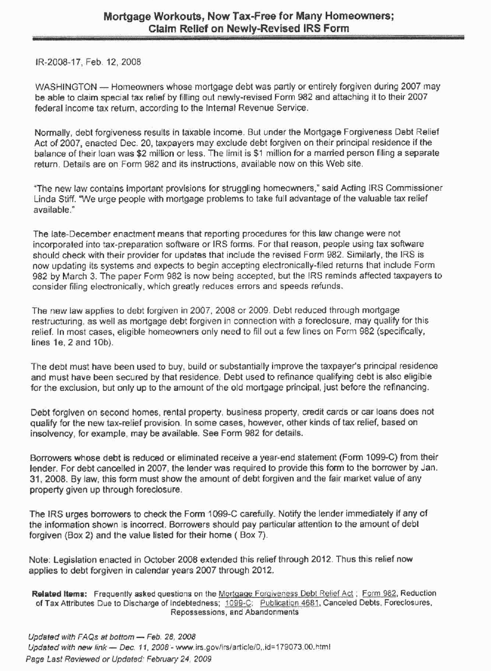

X. UNEARNED INCOME MEDICARE CONTRIBUTION

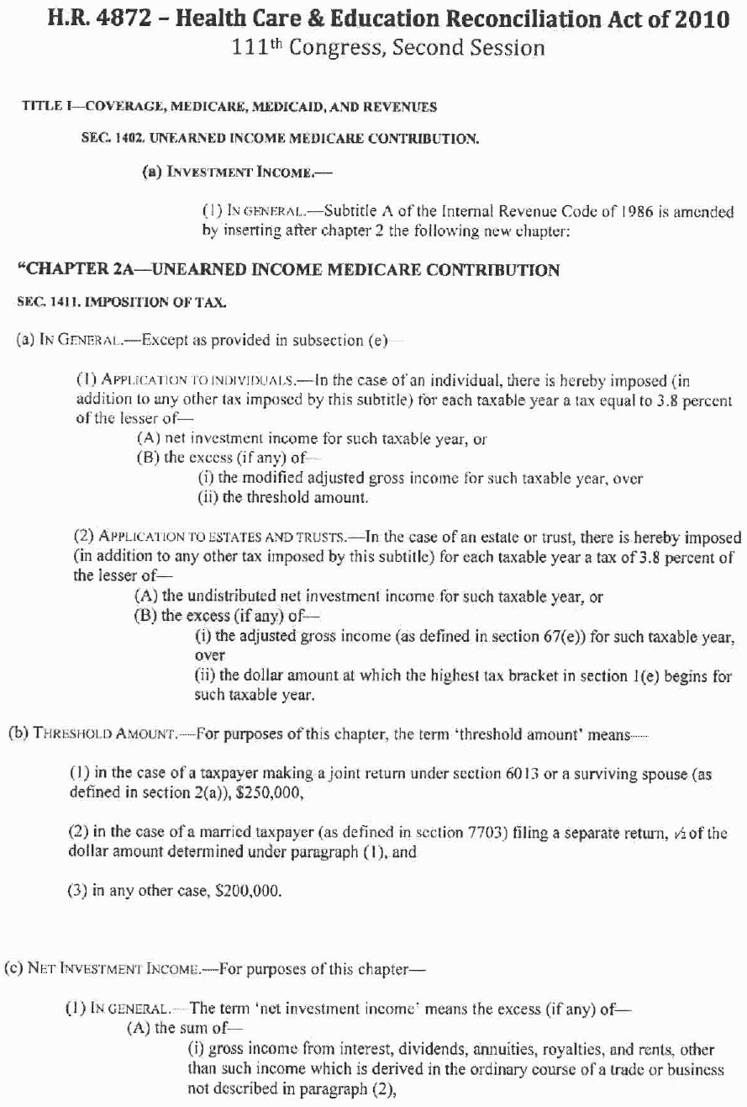

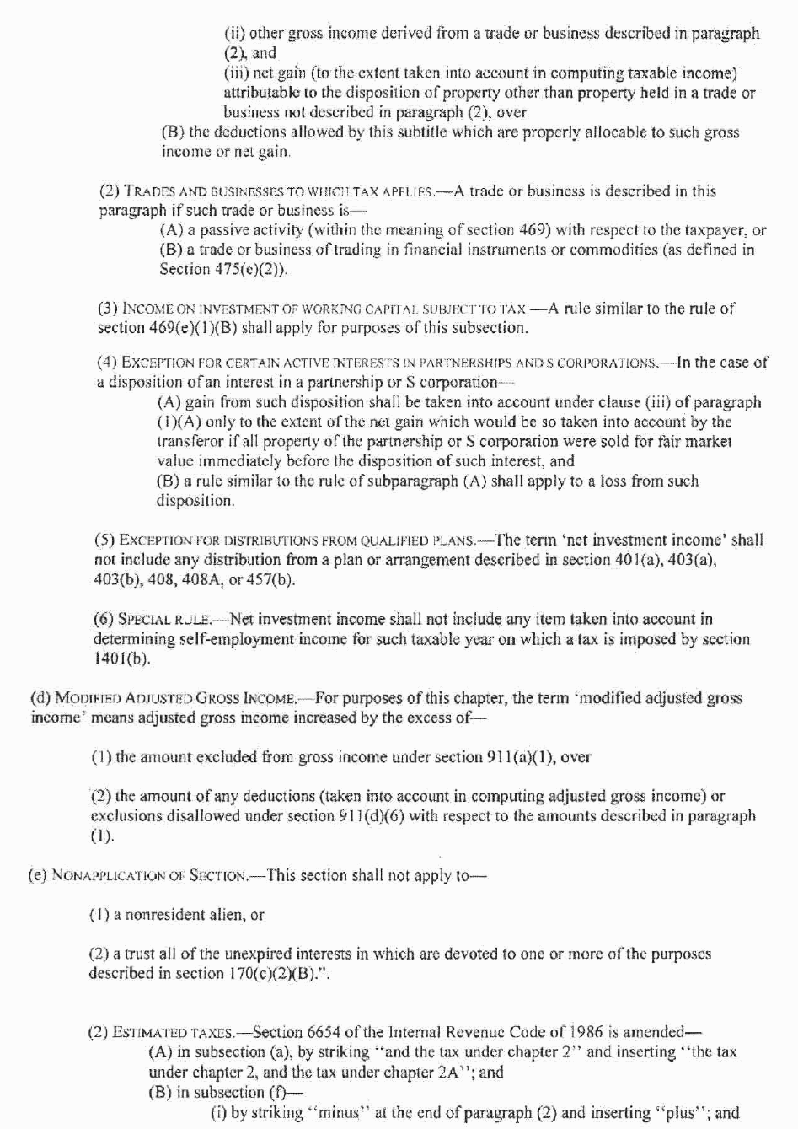
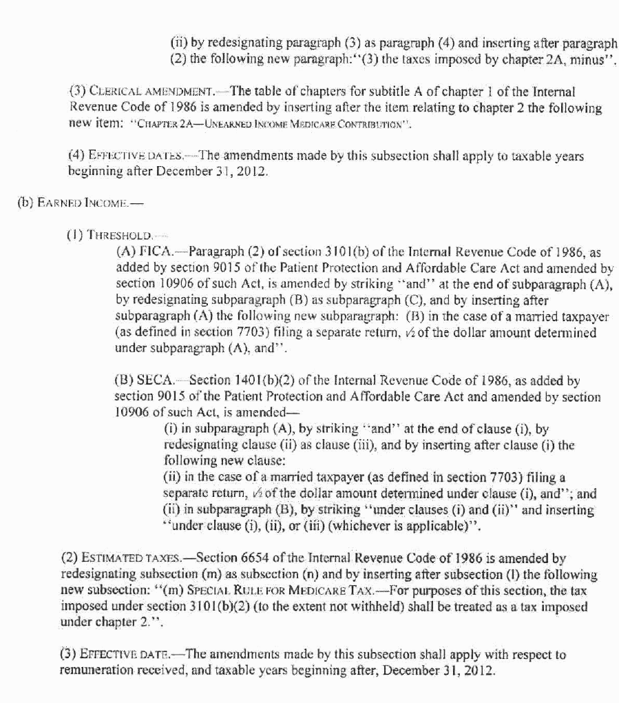

XI. PROTECTING TENANTS AT FORECLOSURE ACT

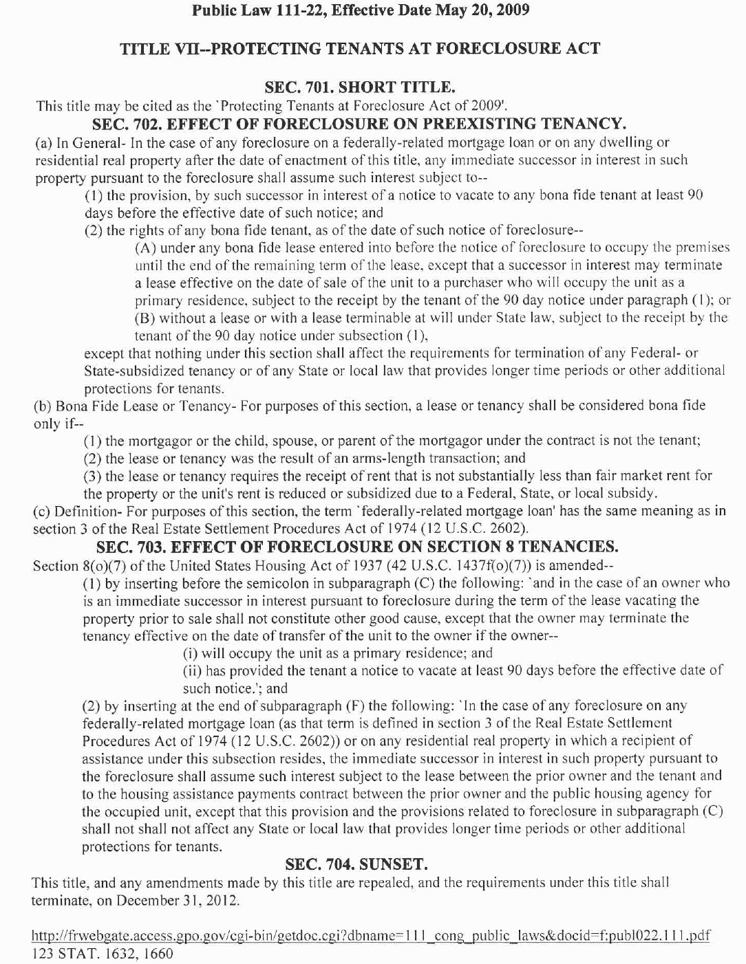

TABLE OF CASES

Cases
Alewine vs. City of Houston, 309 S.W.3d 771 (Tex. App. – 2010) 3
Barr vs. City of Sinton, 295 S.W.3d 334 (Tex.App.-Corpus Christi-Edinburg 2005, pet. granted) 4
Boehl vs. Boley, et al., 2011 WL 238348 (Tex. App. –Amarillo, 2011) 1
Hensley-O’Neal vs. Metropolitan Nat. Bank, 297 S.W.3d 610 (Mo. App. S.D. 2009) 11
Higdon vs. Regions Bank, ___ S.W. 3d ___, 2010 Westlaw 1924019 (Tenn. Ct. App. 5/13/10) 6
In re Tucker, Case No. 10-61004 (W.D. Bkrtcy 9/20/10) 9
Joseph vs. James, 2009 WL 3682608 (Tex. App. –Austin, 2009) 2
MERS vs. Bellistri, 2010 Westlaw 272 0802 (E.D. Mo. 7/1/10) 10
Myrad Properties, Inc. vs. LaSalle Bank National Association, 300 S.W.3d 746, 2009 WL 4877733, 53 Tex. Sup. Ct. J. 208 (Tex. 2009) 7
New Jersey Lawyers’ Fund for Client Protection vs. Stewart Title Guaranty C., A-44-09 (N.J. Super. App. Div. 8/2110) 11
Nguyen vs. Chapa, 305 S.W.3d 316 (Tex.App.-Houston [14th Dist.] 2009, pet. denied) 12
Reyes vs. Egner, 201 N.J. 417, 991 A.2d 216 (2010) 1
Sirdah vs. North Springs Associates, LLLP, 2010 WL 2278184 (Ga. App. 6/8/10) 5
Tiller vs. Shuboney, 894 N.Y.S.2d 342 (N.Y. City Ct. 2009) 5
Wetzel vs. Mortgage Electronic Registration Systems, Inc., ___ S.W.3d ____ (Ark. 2010) 8
Statutes
11 U.S.C. §544(a) 8

